**RECALL BATCH 36H40I ON KOLESTON RED (#54.7)**



EXECUTIVE SUMMARY

In response to customers’ complaints, we analyzed random samples from 5 batches of Koleston Red and we estimated that 6% of the bottles in lot 36H40I are defective. This implies that 0.67% of total production could be compromised, creating significant damage to the image of our future flagship product. We recommend recalling batch 36H40I from the market, followed by a marketing campaign involving a promotion on WELLAton and the institution of a fund for compensating affected customers.

SAMPLING ANALYSIS

In our analysis, we decided to apply a stratified random sampling strategy by adopting the manufacturing dates as strata. Based on the production dates of the reported items, we decided to investigate the products manufactured in the same months, June and November.

We therefore randomly selected 15% of the samples from batches 23J77I, 27Y920, 36H40I, 36PII9, 37AI24. Our sampling choice was aimed at keeping the time frame for analysis relatively low, given the urgency before the release of Garnier’s campaign, while not sacrificing the reliability of a sufficiently large sample. By following the industry standards, we selected a 95% confidence level and noticed that we experienced a quality issue in the manufacturing of batch 36H40I.

ANALYSIS OUTCOME

In batch 36H40I, it was found that from a sample of 42 bottles, 6% of them had a value of Ceteareth–25 above the threshold of 55.7 ml per litre. In fact, we estimated that there might be approximately 70,000 defective bottles in Mexico. This high proportion poses a high risk to our brand image, especially considering that we are projecting 14.3% growth in the hair dye sector; this implies that it is a good time for our proximate competitors to emerge.

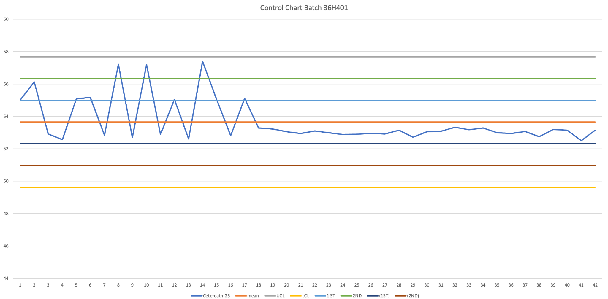

The graph indicates that there has been a dosage error in the earlier stages of production that was later corrected. The plant manager is currently analyzing what happened to reduce this risk in the future.

OUR RECOMMENDATION

Although high Ceteareth-25 is not harmful to health, this would not only damage the launch of the new product, but also the reliability of our company. Indeed, being our data points beyond the three-sigma limit, 6% of the buyers will dye their hair black, while many others will obtain dark colors. We are aware of the economic expense associated with our proposal, but recalling only batch 36H40 from the market will help us limit logistics costs; additionally, it would protect us from negative PR and any fines. To avoid media exposure, we suggest establishing a fund to compensate the clients involved. Also, our case cannot be compared to e-cigarettes, as our chemical unbalance poses no health risk. We recommend reacting differently by taking responsibility towards our mistakes and recalling defective products.

MARKETING STRATEGY

Our biggest concern is not being able to reposition the product on the shelves before Garnier's campaign featuring Dulce Maria. Since the show will be aired in 20 days, we propose to temporarily replace our promotion on Koleston Red with the same shades of our professional label WELLAton. This will make our customers experience the best of what our company offers and will enable us to build brand loyalty. When Koleston Red will be back on the shelves, many customers will choose the cheaper alternative, while others will continue to buy WELLAton at a premium price. In either scenario, we will be proud to say that we have kept our customers at heart and attracted new ones among the younger generation.